INTRODUCTION

1.1 Overview of Sports Analysis and Data Management
In the modern era, sports have evolved beyond physical talent and strategic gameplay. The integration of technology, statistics, and data analytics has revolutionized the way teams, coaches, analysts, and even fans perceive and engage with sports. Sports analysis and data management have become indispensable tools for gaining a competitive edge, optimizing athlete performance, and making data-driven decisions.
Sports analytics refers to the systematic process of collecting, processing, and interpreting various forms of data related to player performance, team tactics, opposition strategies, injury prevention, and even fan engagement. With the advent of powerful computational tools and advanced statistical models, data analytics has transformed the traditional approaches used in sports coaching, scouting, and management. It enables teams to maximize efficiency by leveraging insights derived from historical and real-time data.
Simultaneously, sports data management plays a critical role in ensuring that vast volumes of data are efficiently stored, processed, and retrieved for effective decision-making. Whether it is performance statistics, match footage, biometric data, or fan engagement metrics, an organized and structured data management system is crucial for converting raw information into actionable insights. This requires the use of cloud storage, databases, software applications, and analytical tools that facilitate seamless access to relevant data.
This internship report focuses on the role of sports analytics and data management, specifically in cricket. The internship provided exposure to various analytical methodologies, tools, and software used in the sports industry to assess performance, predict outcomes, and enhance decision-making processes. The experience demonstrated how data is collected, analyzed, and utilized by teams, organizations, and stakeholders to improve the overall effectiveness of the sport.

1.2 The Evolution and Importance of Sports Analytics and Data Management
Sports analytics is not a recent phenomenon; it has been gradually evolving over the past several decades. However, with technological advancements, its scope and impact have expanded exponentially. Early forms of sports analysis relied on basic statistics such as runs scored, goals netted, or fouls committed. Today, analytics go much deeper, utilizing data points such as player movement tracking, physiological responses, reaction times, and even predictive modeling to forecast future performances.
The importance of sports analytics and data management can be understood through multiple dimensions:

1.2.1 Performance Enhancement and Tactical Analysis
One of the primary applications of sports analytics is improving player and team performance. Data is collected through various sources, including match footage, GPS trackers, wearable technology, and real-time performance statistics. This information is then analyzed to:
Identify player strengths and weaknesses.
Optimize training routines based on individual player needs.
Develop game strategies based on data-driven insights.
Analyze in-game performance to make real-time adjustments.
For instance, in cricket, a batsman’s weaknesses against certain types of deliveries (such as short-pitched balls or swinging deliveries) can be identified through analytics, allowing coaches to provide targeted training to overcome these challenges.

1.2.2 Injury Prevention and Athlete Longevity
Injuries are one of the biggest concerns in professional sports. With data analytics, teams can monitor player workloads, biomechanical movements, fatigue levels, and medical histories to reduce injury risks. Sports scientists use predictive models to assess the likelihood of injuries and suggest precautionary measures such as rest days, physiotherapy, and modified training schedules.
For example, in cricket, bowlers are often monitored for workload management, as excessive overs bowled in a short time frame can lead to stress fractures or muscle strains. By using data, coaches can determine the optimal workload for each player, reducing the risk of injury while maintaining peak performance.

1.2.3 Strategic Decision-Making in Matches
Coaches and team managers use real-time and historical data to make informed strategic decisions. By analyzing past performances, player statistics, and opposition tactics, teams can develop more effective game plans. Some key applications include:
Identifying the best batting order based on pitch conditions and opposition bowlers.
Determining the optimal field placements based on a batsman’s shot selection tendencies.
Selecting bowlers based on historical match-ups against specific batsmen.
Using DRS (Decision Review System) to make data-backed appeals for umpiring decisions.
For example, cricket teams use match data to decide whether to bat first or chase, based on statistical probabilities of winning in different conditions. Data-driven decisions often give teams a competitive advantage, increasing their chances of success.

1.2.4 Scouting, Talent Identification, and Recruitment
Recruitment has become increasingly data-driven in professional sports. Scouts and team management use analytics to identify young talent, assess potential signings, and build well-balanced teams. By analyzing player metrics such as:
Strike rates and averages in various match formats.
Bowling speeds, variations, and economy rates.
Physical attributes such as sprint speed and endurance.
Psychological traits such as composure under pressure.
Teams can make informed recruitment decisions. Data-driven scouting ensures that selections are based on objective analysis rather than subjective opinions.

1.2.5 Fan Engagement and Broadcasting Innovations
The role of data extends beyond players and teams. Sports organizations, broadcasters, and digital media platforms use analytics to enhance fan engagement by:
Providing real-time match statistics and visualizations.
Delivering predictive match insights and performance comparisons.
Enhancing fantasy sports platforms with in-depth player analysis.
Using AI-driven analytics for commentary and post-match breakdowns.
Cricket, in particular, has embraced data-driven fan engagement, with leagues like the IPL using data to create innovative viewer experiences, including augmented reality (AR) replays and AI-powered match predictions.

1.3 Role of Sports Analytics in Cricket
Cricket is one of the most data-intensive sports, where every ball, every shot, and every player movement is analyzed in depth. The use of sports analytics in cricket includes:
Batting Analytics – Assessing a player’s scoring patterns, strike rotation tendencies, and effectiveness against different types of bowlers.
Bowling Analytics – Understanding variations, speeds, effectiveness in different conditions, and economy rates.
Fielding Analysis – Tracking fielder reactions, throw accuracy, and defensive placements.
Match Situational Analysis – Determining strategies based on game conditions, such as required run rates, DLS calculations, and pitch behavior.
Advanced technologies like Hawk-Eye, Snickometer, UltraEdge, and ball-tracking systems have revolutionized cricket analytics, providing teams with precise and detailed data to refine their tactics.

1.4 Objectives of the Internship
This internship aimed to provide hands-on experience in sports analytics and data management, specifically focusing on cricket. The key objectives were:
1. Understanding Data Collection Processes – Exploring how cricket-related data is gathered from various sources, including sensors, match footage, and statistical records.
2. Learning Analytical Tools and Techniques – Using software like Python, Excel, Power BI, and sports-specific analytics platforms to analyze data.
3. Applying Data to Performance Evaluation – Examining how data-driven insights help in assessing player and team performance.
4. Developing Predictive Models – Understanding the use of machine learning and statistical modelling to predict match outcomes and player performances.
5. Exploring Real-World Applications – Investigating how teams, franchises, broadcasters, and analysts leverage data for decision-making and fan engagement
Through this internship, a deeper understanding of how data is transforming the world of cricket was gained. The subsequent sections of this report will explore the methodologies, tools, and findings derived from this internship experience, demonstrating the growing impact of sports analytics and data management on modern.

ORGANIZATION PROFILE

Location: https://g.co/kgs/G5mhw3z
Organization: Sports Hub
Organization Size: 5 to 6 (Managers) 60 – 70 (Players)
Headquarters: Bangalore, Karnataka
Type: Proprietor
Founded: 2018
1.5 Overview of the Organization
The organization where this internship was undertaken is a renowned sports organization that specializes in the development, promotion, and management of sports, with a primary focus on cricket. The organization plays a crucial role in enhancing the professional structure of the sport by integrating sports analytics and data management into various aspects of player development, team strategy, and fan engagement.
The organization is committed to advancing cricket through data-driven insights, helping athletes, coaches, and management make informed decisions. By leveraging modern sports science, statistical modeling, and performance analytics, the organization aims to improve player performance, optimize game strategies, and enhance audience engagement. The organization works closely with players, coaching staff, analysts, and sports technologists to refine every aspect of the game through data-backed methodologies.
With a history of supporting both grassroots and professional cricket, the organization serves as a key player in the development of emerging talent, competitive team structures, and international collaborations in the cricketing world.

1.6 Vision and Mission of the Organization
Vision:
To be a leading force in the evolution of cricket through technology, data-driven decision-making, and innovative sports management, ensuring that the sport continues to grow, adapt, and thrive in the modern era.
Mission:
To integrate sports analytics and data management into professional and grassroots cricket.
To enhance player performance through real-time insights, performance tracking, and personalized training programs.
To develop cutting-edge data solutions for coaches and team management to improve strategic decision-making.
To promote fair play and sports integrity using data-driven umpiring and decision review systems.
To engage fans with interactive, data-enhanced experiences, providing deeper insights into the game.

1.7 Services and Operations
The organization operates across multiple domains within cricket and sports analytics, ensuring comprehensive support for players, coaches, franchises, and sports governing bodies.
1. Player Performance Analysis
The organization uses advanced analytics tools to track and analyse player performance, including:
Batting analytics – Strike rates, shot selection tendencies, performance against different bowling styles.
Bowling analytics – Line and length patterns, variations, economy rates, and effectiveness in different conditions.
Fielding analysis – Player reaction time, throwing accuracy, catching efficiency, and overall agility.
2. Match and Opponent Analysis
The organization provides pre-match and post-match analysis reports to teams, allowing them to strategize against opponents effectively. These reports include:
- Historical data trends on opposition teams.
- Pitch condition analysis using past match data and real-time updates.
- Weather impact predictions on game conditions.
- Bowler vs. batsman match-up data to identify potential weaknesses and strengths.
3. Data Management and Technology Integration
To handle vast amounts of cricketing data, the organization employs cloud-based data storage, AI-driven analytics, and automated reporting systems. Key features include:
Real-time performance tracking systems connected to stadium sensors and cameras.
Wearable technology for fitness and biometric monitoring to assess player health and workload.
AI-powered video analysis tools for detailed breakdowns of player techniques.
4. Talent Identification and Scouting
One of the primary focuses of the organization is to identify and nurture young talent through data-driven scouting programs. Using performance analytics, scouts assess:
Emerging players from domestic and junior leagues.
Technical skills, fitness levels, and mental attributes.
Potential for professional contracts with cricket teams.
5. Fan Engagement and Media Analytics
The organization also focuses on enhancing fan experience through data-driven storytelling. This includes:
In-depth match statistics shared during live broadcasts.
Predictive analytics for match results, enabling fans to engage with predictions.
Social media analytics to track audience trends and engagement levels.

1.8 Organizational Structure
The organization is structured to ensure smooth operations across various departments, each focusing on specialized areas of sports analysis and data management. The key divisions include:
1. Cricket Operations Department – Manages player development, coaching programs, and match preparations.
2. Data Analytics and Sports Science Division – Responsible for collecting, processing, and analysing player and match data.
3. Technology and Innovation Team – Develops and integrates software solutions for performance tracking and fan engagement.
4. Scouting and Talent Development Unit – Identifies promising players and facilitates their growth.
5. Marketing and Media Division – Handles social media, audience engagement, and data-driven content creation.
6. Partnerships and Sponsorship Team – Manages collaborations with sports brands, governing bodies, and tech firms.
1.9 Achievements and Contributions
The organization has made significant contributions to the development of cricket analytics and data management by implementing innovative technologies and methodologies. Some key achievements include:
Successfully implementing AI-driven match analysis tools to assist coaches in game strategy planning.
Partnering with major cricket leagues to provide in-depth analytics reports for teams and broadcasters.
Developing wearable fitness tracking solutions to help players optimize their training and recovery.
Supporting young cricketers through talent scouting programs, leading to professional contracts for many promising players.
Enhancing fan engagement by integrating data-driven insights into live match experiences through advanced graphical overlays and interactive statistics.

1.10 Future Goals and Expansion Plans
The organization continuously strives to innovate and expand its influence in the world of cricket and sports analytics. Future plans include:
Expanding sports analytics coverage to include more domestic leagues and international tournaments.
Enhancing AI and machine learning capabilities to improve predictive analytics in cricket.
Developing a comprehensive mobile application that provides real-time analytics for players, coaches, and fans.
Establishing partnerships with international cricket boards and sports universities for research in performance optimization.
Exploring new areas in sports biomechanics and injury prevention analytics to enhance player longevity.

1.11 Conclusion
The organization plays a vital role in shaping modern cricket by utilizing sports analytics and data management. By combining scientific analysis with real-world gameplay insights, it has established itself as a leader in cricket performance optimization, strategic decision-making, and fan engagement.
Through its commitment to innovation, technology, and data-driven methodologies, the organization continues to push the boundaries of cricketing excellence, ensuring that players, coaches, and fans benefit from the most advanced analytical tools available.
This internship provided an invaluable opportunity to explore how a professional sports organization functions, offering insights into sports analytics, data management, and real-world applications in cricket. The experience gained during this internship is a testament to the organization’s commitment to the advancement of cricket and the transformative power of data-driven sports management.

WORK DISCRIPTION

During my internship at a sports-focused firm affiliated with Bangalore University, I was actively involved in the domain of Sports Analysis and Data Management, with a primary focus on cricket analytics. My role was centered around assisting in the collection, organization, and interpretation of cricket-related data to support performance evaluation and strategic planning.
My key responsibilities included gathering match and player performance data from both live games and historical records. This data was systematically recorded and organized using Microsoft Excel and Google Sheets, where I maintained weekly performance trackers that covered statistics such as runs, strike rate, wickets, economy, and fielding accuracy.
I contributed to preparing player profiles and comparative performance charts which were later used by coaches and analysts for pre-match evaluations. I also worked on creating simple visual dashboards to represent team performance trends using tools like Power BI and Excel charts.
During the internship, I had the opportunity to collaborate with the analytics team and occasionally interact with coaching staff to understand the tactical importance of data. I learned the fundamentals of sports data lifecycle — from collection to actionable insight — and how data-driven decisions are shaping modern cricket strategies.
This hands-on experience enhanced my skills in data handling, performance evaluation, and teamwork. It gave me a real-world perspective on how analytics influences team decisions and player development in the world of sports.
The below following are discussions made during the internship of 30 days which is briefly described.
PREFACE

2.1 Meaning Of Sports Analytics
Sports analytics are collections of relevant historical statistics that can provide a competitive advantage to a team or individual by helping to inform players, coaches and other staff and help facilitate decision-making both during and prior to sporting events. The term "sports analytics" was popularized in mainstream sports culture following the release of the 2011 film Moneyball. In this film, Oakland Athletics general manager Billy Beane (played by Brad Pitt) relies heavily on the use of baseball analytics to build a competitive team on a minimal budget, building upon and extending the established practice of Sabermetrics.
There are two key aspects of sports analytics—on-field and off-field analytics. On-field analytics deals with improving the on-field performance of teams and players, including questions such as "which player on the Red Sox contributed most to the team's offense?" or "who is the best wing player in the NBA?", etc. Off-field analytics deals with the business side of sports. Off-field analytics focuses on helping a sport organization or body surface patterns and insights through data that would help increase ticket and merchandise sales, improve fan engagement, etc. Off-field analytics essentially uses data to help rights-holders make decisions that would lead to higher growth and increased profitability.
  - Advantages
Improved Performance:
Analysis of player data can identify areas for improvement in technique, fitness, and decision-making.
Coaches can use data to tailor training programs and optimize player development.
Enhanced Strategic Decision-Making:
Analyzing opponent data allows teams to identify weaknesses and develop effective game plans.
In-game analytics can provide real-time insights to adjust strategies and make crucial decisions.
Injury Prevention:
Analyzing biometric data can help identify risk factors for injuries and implement preventive measures.
Monitoring player workload can help prevent overtraining and reduce injury risk.
Objective Evaluation:
Data-driven analysis reduces bias and provides a more objective assessment of player and team performance.
This can lead to fairer evaluations and more informed decisions.
Optimization of resources:
Sports organizations can optimize business decisions regarding, ticket sales, and marketing.
2.3 Disadvantages
Data Limitations:
Not all aspects of sports can be easily quantified, and some crucial factors may be missed by data analysis.
The quality and availability of data can vary, affecting the accuracy of analysis.
Over-Reliance on Data:
Over-reliance on data can lead to neglecting intuition and experience, which are also valuable in sports.
The "human element" of sports, such as motivation and mental toughness, can be difficult to quantify. Complexity and Cost:
Advanced sports analytics requires sophisticated tools, software, and expertise, which can be expensive. Interpreting complex data requires specialized skills and knowledge.
Potential for Misinterpretation:
Data can be misinterpreted, leading to flawed conclusions and poor decisions.
It is important to understand the context of the data.
Ethical Considerations:
The collection and use of player data raise ethical concerns about privacy and potential misuse.
In essence, sports analysis is a powerful tool that can provide valuable insights, but it's essential to use it judiciously and in conjunction with other factors.

2.4 Types Of Sports Analysis
a) Performance Analysis
Evaluates individual and team performances through video and statistical data.
Used by coaches to improve skills, techniques, and decision-making.
Example: In cricket, analyzing a batsman’s shot selection against different types of bowlers.
b) Tactical Analysis
Studies formations, strategies, and patterns of play in a game.
Helps teams adjust tactics against opponents
Example: In football, understanding how a team builds play from defense to attack.
c) Biomechanical Analysis
Uses motion tracking to examine an athlete’s movements.
Helps in injury prevention, rehabilitation, and performance optimization.
Example: Studying a bowler’s action in cricket to reduce injury risk.
d) Data Analytics in Sports
Uses statistical models, AI, and machine learning to interpret sports data.
Predicts match outcomes, player performance, and game strategies.
Example: Predicting the winning probability of a cricket match based on historical performance.
e) Sentiment & Social Media Analysis
Tracks fan engagement, team reputation, and sponsorship impact.
Helps teams and brands tailor marketing campaigns.
Example: Analyzing social media reactions to a player’s performance in the IPL.

2.5 Key Technologies Used in Sports Analysis
a) Video Analytics
Tools: Hudl, Catapult, Sportscode.
Helps in reviewing player performances by analyzing movement, positioning, and decision-making.
Example: Cricket teams use video analysis to study opposition bowlers and batsmen.
b) Hawk-Eye Technology
Tracks ball movement, trajectory, and decision-making accuracy.
Used in cricket (DRS), tennis, and football (goal-line technology).
c) Wearable Sensors & GPS Trackers
Monitors players’ heart rate, fatigue levels, and movement during matches.
Helps optimize training loads and prevent injuries.
Example: In football and cricket, GPS vests track players’ running distance and intensity.
d) Artificial Intelligence & Machine Learning
AI models analyze player performance, predict injuries, and optimize team selection.
Example: AI-powered scouting systems identify future cricket stars based on domestic performances.
e) Big Data & Cloud Computing
Stores and processes large volumes of match data in real-time.
Helps teams make data-driven decisions.
Example: Cricket teams use cloud databases to track player form across multiple seasons.


2.6 Meaning of Data Management
Data management refers to the systematic collection, storage, organization, and analysis of data to ensure its accuracy, security, and accessibility. It plays a crucial role in sports analytics, where vast amounts of data are generated from matches, player performances, training sessions, and fan interactions.
In sports, effective data management helps in:
Improving player performance
Optimizing team strategies
Enhancing fan engagement
Preventing injuries
Supporting real-time decision-making

2.7 Components of Data Management in Sports
a) Data Collection
This involves gathering raw data from multiple sources such as:
Player Tracking Systems – GPS trackers, wearables (heart rate monitors, accelerometers)
Match Data – Ball-by-ball records, scorecards, video footage
Social media & Fan Engagement – Sentiment analysis from tweets, posts, and comments
Performance Metrics – Speed, agility, shot accuracy, bowling speeds, batting strike rates
Example in Cricket:
Hawk-Eye technology records ball trajectories.
Wearable sensors track players' fitness levels.
Match analysts manually input game stats.
b) Data Storage
Once collected, data must be stored efficiently for retrieval and analysis.
Relational Databases (SQL, MySQL, PostgreSQL) – Used for structured data like match statistics.
NoSQL Databases (MongoDB, Firebase) – Used for unstructured data like social media feeds.
Cloud Storage (AWS, Google Cloud, Azure) – Used for large datasets and real-time data sharing.
Data Lakes & Warehouses – Store historical and real-time data for advanced analytics.
Example in Cricket:
A central database stores player statistics across different tournaments.
Video footage is archived in cloud servers for future tactical analysis.
c) Data Processing & Cleaning
Raw data often contains errors, duplicates, or inconsistencies. Data processing involves:
Cleaning – Removing duplicate, incorrect, or irrelevant data.
Normalization – Standardizing data formats for consistency.
Integration – Merging data from different sources into a unified system.
Real-time Processing – Streaming data analysis during live matches.
Example in Cricket:
Cleaning duplicate player records if a batsman appears under multiple spellings (e.g., "M.S. Dhoni" vs. "MS Dhoni").
Converting raw ball-by-ball data into structured insights (dot-ball %, strike rate).
d) Data Security & Privacy
Sports data contains sensitive information that must be protected. Key measures include:
Encryption – Securing player and team data from cyber threats.
Access Control – Restricting data access to authorized personnel only.
Regulatory Compliance – Following data protection laws (GDPR, Indian IT Act).
Example in Cricket:
A team's injury data is kept confidential to prevent opponents from gaining an advantage.
e) Data Analysis & Visualization
Descriptive Analytics – Summarizes past performances (e.g., a batsman's average against left-arm pacers).
Predictive Analytics – Uses AI/ML to forecast match outcomes (e.g., predicting IPL winners based on historical data).
Prescriptive Analytics – Suggests strategies (e.g., the best bowling lineup for a given pitch).
Data Visualization – Graphs, dashboards, and reports help analysts and coaches understand trends.
Example in Cricket:
A heatmap showing a batsman’s most frequent scoring areas against spin bowlers.

2.8 Uses of Data Management in Sports Analytics
a) Player Performance Tracking & Improvement
Monitors key performance indicators (KPIs) such as strike rate, bowling economy, and fitness levels.
Helps coaches design personalized training programs.
AI-powered video analysis detects batting and bowling flaws.
Example:
Tracking a bowler's variations across different overs to improve death-over execution.
b) Game Strategy & Tactical Decisions
Helps coaches devise match-winning tactics based on opposition weaknesses.
Provides real-time suggestions for captaincy decisions (e.g., bowling changes, field placements).
Example:
Data shows that a batsman struggles against short-pitched deliveries, so the team sets a field accordingly.
c) Injury Prevention & Load Management
Workload tracking (overs bowled, distance covered) helps prevent injuries.
Wearable sensors monitor fatigue levels in real-time.
AI predicts injury risks based on workload trends.
Example:
Managing a fast bowler’s workload to avoid stress fractures by limiting overs per match.
d) Fan Engagement & Marketing Analytics
Uses social media data to gauge public sentiment and player popularity.
Enhances the fan experience through personalized content (fantasy leagues, interactive stats).
Example:
AI recommends fantasy league team selections based on real-time performance trends.
e) Broadcast & Media Enhancement
Data-driven graphics improve the viewing experience.
Augmented reality overlays display real-time stats on-screen.
AI-generated match summaries for quick recaps.
Example:
Win probability charts shown during IPL matches are powered by data models.

DEEP DIVE
2.9 Meaning of Finance
Finance refers to the management, creation, and study of money, investments, and financial systems. It involves activities like budgeting, investing, lending, borrowing, and forecasting. Finance can be categorized into three main areas:
1. Personal Finance – Managing individual or household money, including savings, investments, budgeting, and retirement planning.
2. Corporate Finance – Handling a company’s financial activities, such as capital structuring, investments, and risk management.
3. Public Finance – Managing government revenues, expenditures, and debt to support economic stability.
4. Sports Finance - Sports finance refers to the management of money, investments, and financial planning within the sports industry. It involves handling revenues, expenses, sponsorships, broadcasting rights, player salaries, team valuations, and overall financial decision-making in sports organizations.

2.10 Impact of Finance
Financial aspects significantly impact sports analysis by influencing data collection, technology, player performance evaluation, and overall decision-making.
Revenue Streams in Sports Analytics - Sports analytics generates revenue from multiple sources, which fund data collection, analysis, and decision-making.

2.10.1 Sponsorship & Advertising
Sponsorship and advertising are major revenue sources in sports analytics, influencing financial decisions, technological advancements, and fan engagement. Companies invest in sports teams, leagues, and events to gain brand exposure, while teams use these funds to enhance performance through data analytics.
- Definition of Sports Sponsorship
Sponsorship is a financial or in-kind support provided by a brand or company to a sports entity (team, league, event, or individual athlete) in exchange for promotional benefits.
Types of Sponsorship in Sports Analytics
1.Title Sponsorship
A brand sponsors an entire league, tournament, or major event.
Example: TATA is the title sponsor of IPL, contributing millions for branding rights.
Impact on Analytics: Higher revenue allows teams to invest in advanced analytics like player tracking and performance monitoring.

2. Team Sponsorship
Companies sponsor specific teams in exchange for logo placement on jerseys, merchandise, and digital platforms.
Example: BYJU’S sponsored the Indian cricket team’s jersey.
Impact on Analytics: Teams allocate sponsorship funds toward sports scientists, wearable tech, and data visualization tools.

3. Athlete Sponsorship
Individual players endorse brands, promoting products through advertisements and social media.
Example: Virat Kohli’s association with Puma involves real-time performance tracking for marketing campaigns.
Impact on Analytics: Brands use player performance data to create personalized marketing campaigns.
4. Technology & Data Sponsorship
Tech firms provide hardware, software, or analytics tools to teams or leagues.
Example: SAP partnered with the NBA to provide advanced player analytics.
Impact on Analytics: Teams get access to cutting-edge AI-driven analytics at reduced costs.

5. Broadcast Sponsorship
Media companies integrate brand promotions during live telecasts and digital content.
Example: Star Sports integrates match statistics with sponsored segments like “CEAT Tyres Strategic Timeout” in IPL.
Impact on Analytics: Broadcast data analytics improve fan engagement, making sponsorships more valuable.

- Definition of Sports Advertising
Sports advertising refers to promotional activities that use sporting events, teams, or athletes as a medium to reach a large audience.
Types of Advertising in Sports Analytics
1. Digital & Social Media Advertising
Teams and athletes post performance stats and match analysis, integrating brand messages.
Example: Cristiano Ronaldo’s Instagram posts featuring Nike after key matches.
Impact on Analytics: AI-driven sentiment analysis determines which ads perform best.

2. Stadium & Venue Advertising
Billboards, LED screens, and virtual advertisements placed inside stadiums.
Example: Coca-Cola banners at FIFA World Cup stadiums.
Impact on Analytics: Advanced camera tracking ensures dynamic ad placements based on audience demographics.

3. In-Game Advertising
Brands integrate logos, product placements, or sponsored segments during broadcasts.
Example: "UltraEdge Analysis powered by Paytm" in cricket matches.
Impact on Analytics: Viewer engagement data helps optimize ad placement.

4. Fantasy Sports & Betting Advertisements
Betting companies advertise using live match analytics.
Example: Dream11 ads during cricket matches encourage users to use match statistics for fantasy predictions.
Impact on Analytics: Real-time odds calculation and AI predictions make betting ads more effective.

5. Branded Content & Influencer Marketing
Brands create sports-related content featuring analytics insights.
Example: Nike’s data-driven video campaign on athlete performance.
Impact on Analytics: Machine learning helps optimize ad targeting based on user preferences.

- Financial Impact of Sponsorship & Advertising on Sports Analytics
1.Revenue Growth for Teams & Leagues
Sponsorships and ads contribute 30-50% of total revenue for major sports organizations.
Example: IPL title sponsorship alone is worth ₹500 crore+ annually, funding better analytics and player scouting.

2.Increased Investment in Sports Technology
More sponsorship money allows for advanced analytics systems, AI-powered scouting, and injury prevention tools.
Example: La Liga’s deal with Microsoft helped create AI-driven player tracking software.

3.Higher Brand Engagement Through Data Analytics
Predictive analytics help brands target the right audience for ads.
Example: Adidas uses AI to analyze fan behavior and optimize product promotions.

4. ROI Measurement for Sponsors
Sponsors use engagement metrics, audience demographics, and performance analytics to measure ad effectiveness.
Example: Brands track jersey sales before and after an athlete’s endorsement deal.

2.10.2 Broadcasting Rights
Broadcasting rights refer to the exclusive permission given to media companies (TV networks, streaming platforms) to broadcast live or recorded sports events for a specific period and region. These deals are signed between sports leagues and broadcasters, generating billions in revenue.
Types of Broadcasting Rights
1. Live Broadcast Rights
Allows TV networks and digital platforms to air matches in real-time.
Example: Star Sports holds exclusive IPL broadcasting rights.

2. Highlights & Post-Match Rights
Media companies can show match highlights after the event.
Example: ESPN gets rights to show Premier League match recaps.

3. Streaming & Digital Rights
Online platforms pay for exclusive digital broadcasting.
Example: Viacom18 (JioCinema) secured IPL’s digital rights for ₹23,758 crore.

4. Regional & International Rights
Different companies get rights for specific countries.
Example: Sky Sports broadcasts the EPL in the UK, while NBC has rights in the USA.

5. Radio & Audio Rights
Deals for audio commentary on radio or podcasts.
Example: BBC Radio owns broadcasting rights for FIFA World Cup commentary.

Financial Impact of Broadcasting Rights
Broadcasting deals bring massive revenue, which is reinvested in sports analytics, player scouting, and fan engagement.
1. Revenue Generation for Leagues & Teams
Sports leagues sell broadcasting rights for billions, with revenue shared among teams.
Example: The English Premier League’s broadcasting deal is worth £6.7 billion.

2. Increased Investment in Sports Analytics
More revenue allows teams to invest in AI-based sports analytics, wearable tech, and injury prevention tools.
Example: The NBA uses Second Spectrum AI-powered analytics to enhance broadcasts.

3. Data Monetization Through Analytics
AI-driven match analysis is sold to broadcasters to enhance coverage.
Example: The IPL uses Hawk-Eye for ultra-edge technology, funded by TV rights revenue.

4. Growth of Streaming Platforms
Digital platforms like Hotstar, JioCinema, and Amazon Prime are spending billions to acquire streaming rights.
Example: The NFL’s deal with Amazon Prime for exclusive Thursday Night Football broadcasts.

2.10.3 Blockchain
Blockchain technology is transforming the financial landscape of sports by increasing transparency, security, and efficiency in financial transactions. Here’s how it impacts various aspects of sports finance:
1. Secure & Transparent Transactions
Blockchain enables tamper-proof financial records, ensuring transparency in ticket sales, sponsorship deals, and club financial transactions.
Reduces fraud in sports betting and sponsorship agreements.

2. Tokenization & Fan Engagement
Sports teams issue fan tokens (e.g., Chiliz & Socios) to give fans voting rights on team decisions.
Fans can trade tokens, access exclusive content, and get rewards, creating new revenue streams.

3. Smart Contracts for Player Salaries & Transfers
Automates salary payments and contract bonuses, reducing disputes.
Ensures instant payments in international transfers without intermediaries.

4. NFTs & Digital Collectibles
Teams and leagues sell NFT-based memorabilia (digital trading cards, video highlights) for additional revenue.
Platforms like NBA Top Shot have revolutionized digital sports collectibles.
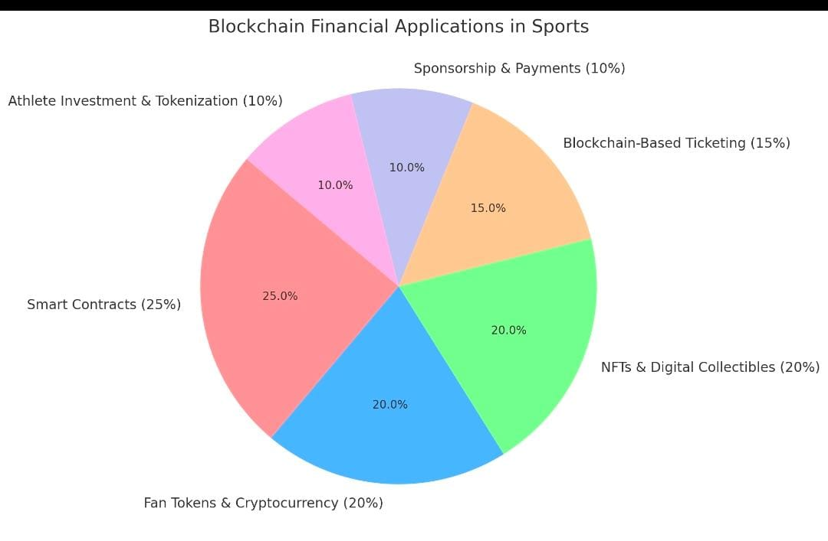
2.10.4 Budget In Sports
A sports budget is a financial plan that outlines the estimated income and expenses for a sports team, club, league, or event over a specific period. It helps organizations manage resources efficiently, control costs, and ensure financial stability.

Key Components of a Sports Budget
1. Revenue Sources (Income)
Ticket Sales – Revenue from matchday ticket purchases.
Sponsorships & Advertising – Deals with brands and companies.
Broadcasting Rights – TV and streaming contracts for matches.
Merchandising – Sales of jerseys, fan gear, and memorabilia.
Player Transfers – Income from selling players in professional sports.
Government & Grants – Funding for sports development programs.

2. Expenses (Costs)
Player Salaries & Transfers – Wages, bonuses, and acquisition costs.
Facility Maintenance – Stadium and training ground upkeep.
Travel & Accommodation – Costs for away games and international tours.
Coaching & Staff Salaries – Payments for management, medical staff, and trainers.
Marketing & Promotions – Advertising campaigns to boost fan engagement.
Event Costs – Expenses for organizing leagues, tournaments, and championships.

Impact of Budget on Sports Finance
A budget plays a crucial role in managing the financial stability and growth of sports organizations, teams, and events. Proper budgeting ensures that sports entities allocate resources efficiently, maximize revenues, and minimize financial risks.
1. Financial Planning & Resource Allocation
Helps sports teams and organizations distribute funds for player salaries, stadium maintenance, training, and marketing.
Ensures a balance between spending and revenue generation to avoid financial losses.

2. Player Salaries & Transfers
A well-planned budget prevents overspending on player contracts and transfer fees.
Clubs with strong budgeting (e.g., Manchester City, Real Madrid) maintain a competitive edge without financial instability.
Poor budgeting can lead to bankruptcy, as seen in cases like FC Barcelona’s financial struggles.
3. Revenue Generation & Profitability
Helps teams plan for multiple revenue streams: ticket sales, broadcasting rights, sponsorships, and merchandising.
Allows organizations to invest in long-term profitability, such as building new stadiums or launching digital fan engagement initiatives.

4. Cost Control & Risk Management
Budgeting helps identify unnecessary expenses and optimize spending.
Reduces financial risks related to injuries, legal disputes, or economic downturns.
Ensures financial sustainability during off-seasons or global crises (e.g., COVID-19 pandemic impact on sports revenues).

5. Youth Development & Infrastructure
Allows clubs and organizations to invest in academies, talent scouting, and training facilities.
Enhances long-term team performance while reducing future player acquisition costs.

6. Event Management & Tournament Planning
Budgeting is crucial for organizing major sports events (e.g., FIFA World Cup, IPL, Olympics).
Ensures controlled spending on stadium construction, security, broadcasting, and marketing to maximize profitability.

2.10.5 Taxation In Sports
Tax in sports refers to the various taxes imposed on athletes, teams, leagues, event organizers, and sports-related businesses. These taxes impact earnings, sponsorship deals, player transfers, and overall financial management in the sports industry.
Types of Taxes in Sports
1. Income Tax on Athletes
Professional athletes pay income tax on salaries, bonuses, and endorsement deals.
Tax rates vary by country and state, affecting contract negotiations and net earnings.
Example: In the UK, top athletes pay up to 45% in income tax, while in Monaco, there is no income tax.

2. Corporate Tax on Sports Teams & Clubs
Sports franchises pay corporate tax on profits from ticket sales, merchandise, and broadcasting rights.
Some clubs register as non-profit organizations to benefit from tax exemptions (e.g., FC Barcelona, Real Madrid).

3. Sponsorship & Endorsement Taxation
Taxes are applied to sponsorship income for both athletes and teams.
Some countries offer tax breaks to companies investing in sports sponsorships.
Example: In India, businesses sponsoring cricket teams can claim tax deductions as marketing expenses.

4. Ticket Sales & Merchandise Tax
Governments impose sales tax or VAT on match tickets and sports merchandise.
High taxes may lead to increased ticket prices, affecting fan attendance.
5. Luxury Tax in Leagues
Some leagues (NBA, MLB) impose a luxury tax on teams that exceed salary caps.
The extra tax is redistributed to smaller teams, ensuring financial parity.
Example: The NBA luxury tax forces high-spending teams (e.g., Golden State Warriors) to pay penalties.

6. Tax on Player Transfers & Agent Fees
Clubs may be required to pay capital gains tax on profits from player sales.
Agents earning commission on transfers also face taxation.
Some clubs structure deals to minimize tax liabilities (e.g., using performance-based bonuses).

7. Taxation on Major Sports Events
Hosting countries may provide tax exemptions to attract global events like the FIFA World Cup or Olympics.
Example: Brazil granted tax breaks to FIFA for the 2014 World Cup.

Impact of Taxation on Sports Finance
✅ Encourages financial transparency and compliance.
✅ Affects player earnings and contract negotiations.
✅ Impacts ticket prices, sponsorship deals, and team budgets.
✅ Influences investment in sports infrastructure and event planning.
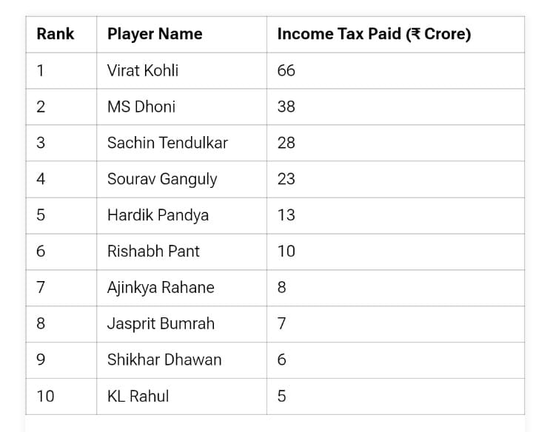

LEARNING OUTCOMES

During the course of my internship in Sports Analytics and Data Management, I gained an in-depth understanding of how data-driven approaches are revolutionizing the field of sports, especially in cricket. I learned how the integration of technology and analytics is not only enhancing player performance but also supporting coaches, analysts, and management in making informed decisions. One of the most significant outcomes was my ability to work with real-world sports datasets, where I was responsible for collecting raw data from various match sources, cleaning it to ensure accuracy, and organizing it into structured formats suitable for analysis. I explored different tools and software including Microsoft Excel, Python libraries such as Pandas and Matplotlib, and data visualization platforms like Power BI and Tableau, which helped me visualize trends and performance metrics effectively.
I developed a strong foundation in identifying key performance indicators (KPIs) specific to cricket, such as batting and bowling averages, strike rates, economy rates, player consistency, win probabilities, and opposition analysis. These KPIs were not only statistically evaluated but also interpreted in a contextual manner to draw actionable insights. This process taught me how to bridge the gap between raw data and strategic decisions, which is essential for team selection, match planning, and post-match reviews.
As the internship progressed, I was introduced to various performance metrics commonly used in cricket, such as batting averages, strike rates, bowling economy, and player consistency indexes. I learned how to analyze individual and team performances using both traditional and advanced statistical methods. I also worked with data visualization techniques, creating graphs and dashboards that helped in presenting the data in a more understandable and actionable format.
In addition to the technical learning, I also observed how sports analysts use data to make strategic decisions. I was exposed to real-life scenarios where performance data influenced team selection and tactical changes. I had the opportunity to participate in discussions where my observations and reports were used as part of the broader analysis team. Finally, this internship improved my ability to present insights clearly through written reports and visual presentations, strengthening both my analytical and communication skills.
Additionally, I was introduced to predictive analytics and machine learning concepts, where I understood how historical data could be used to forecast player performance and match outcomes. I also learned the importance of real-time data tracking and how it is used during live matches for performance monitoring and on-the-spot strategic adjustments.
Beyond technical skills, the internship greatly improved my critical thinking, problem-solving ability, and attention to detail. I also developed communication skills through report writing and presentations, where I learned to convey complex data findings in a simple and engaging manner to non-technical audiences. Overall, this internship provided me with a holistic view of how data and analytics are becoming essential components of modern sports management and gave me the confidence to pursue a career in this dynamic and evolving field.
As the expected result from internship is described below in the form of case study:
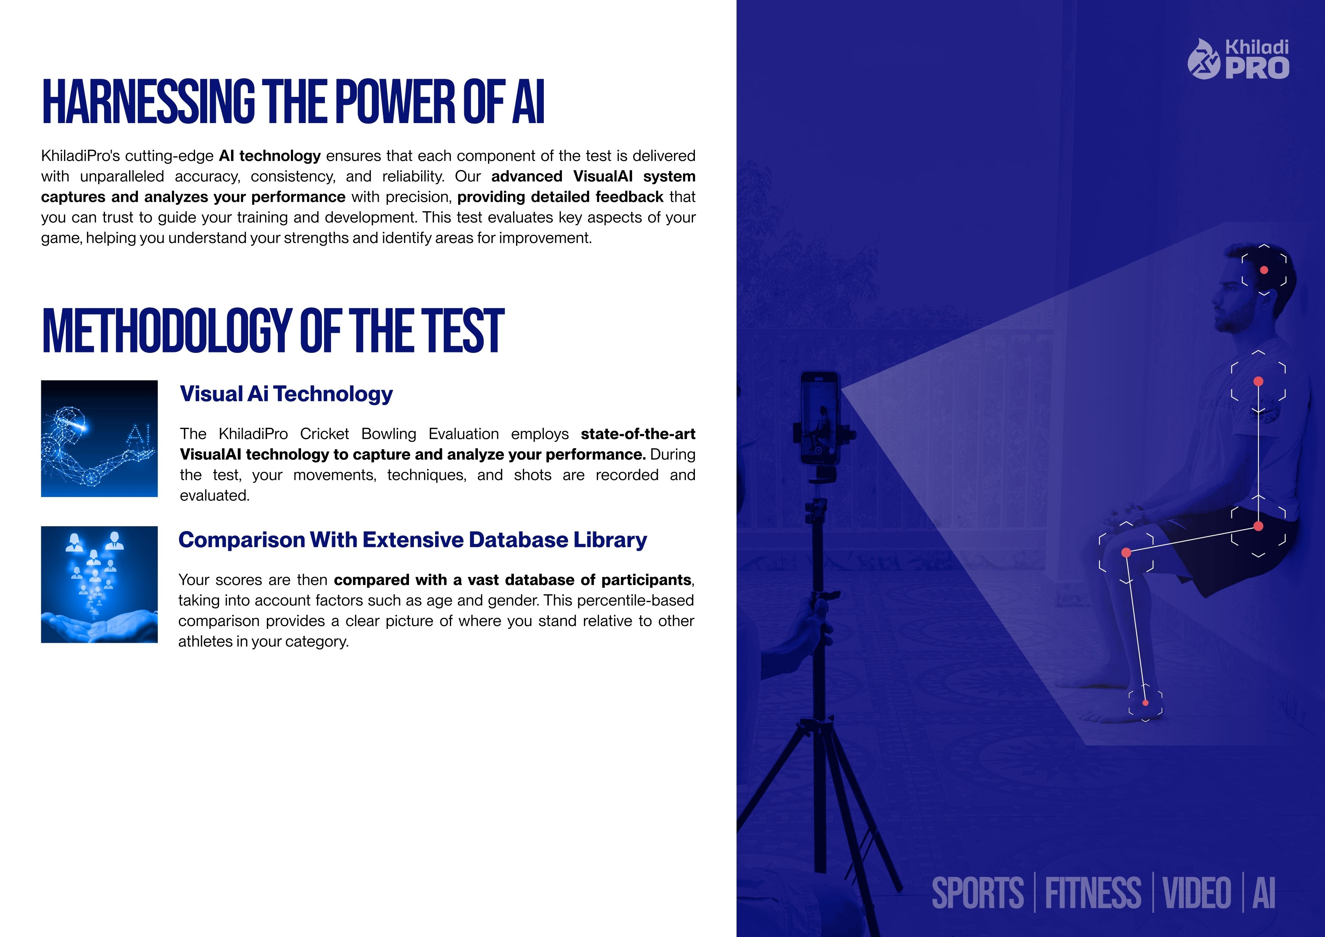
CASE STUDY

Jan 2025
A+ A B+ B C+ C D
Batting Evaluation
KhiladiPro's visual AI technology, here's a detailed analysis of your cricket batting performance.
The player's skill map shows good top-hand control, but there is a lack of drills in power, grip, running, balance, and backfoot technique. Focus on incorporating drills for grip, power, running, balance, and backfoot skills to develop a more balanced and effective skill set.

Sr No Name of test
01 Top hand drill

Power
Point of contact
100
80
60
40
20
Balance
Running b/w Wickets
Gripp
Controlol
Batting Evaluation A
The player's skill map shows good top-hand control, but there is a lack of drills in
power, grip, running, balance, and backfoot technique. Focus on incorporating
drills for grip, power, running, balance, and backfoot skills to develop a more
balanced and effective skill set.

RAHUL | MALE | 20 YEARS | RIGHT HANDED

Academy: Kreesha Cricket Academy, Assessment Date: 03-01-2025
Top Hand Drill 8.3/10
The Top Hand Drill in cricket strengthens the top hand's control, enhancing shot stability, precision, and balance for better stroke play


Scan to view the video

TOP HAND DRILL A

Top Hand Drill Top Hand Drill Map


KHILADI
PRO

Return direction
Insights: Balls 3 and 4 showcased good shot accuracy, particularly in the cover region, reflecting solid technique and timing. Balls 1, 2, 5, and 6 struggled with accuracy, particularly for point shots, suggesting issues with alignment or shot selection.
Improvements: Focus on refining point shots and improving timing and alignment for off-stump deliveries. Practicing better foot placement and shot execution will help achieve more consistent accuracy like Balls 3 and 4.
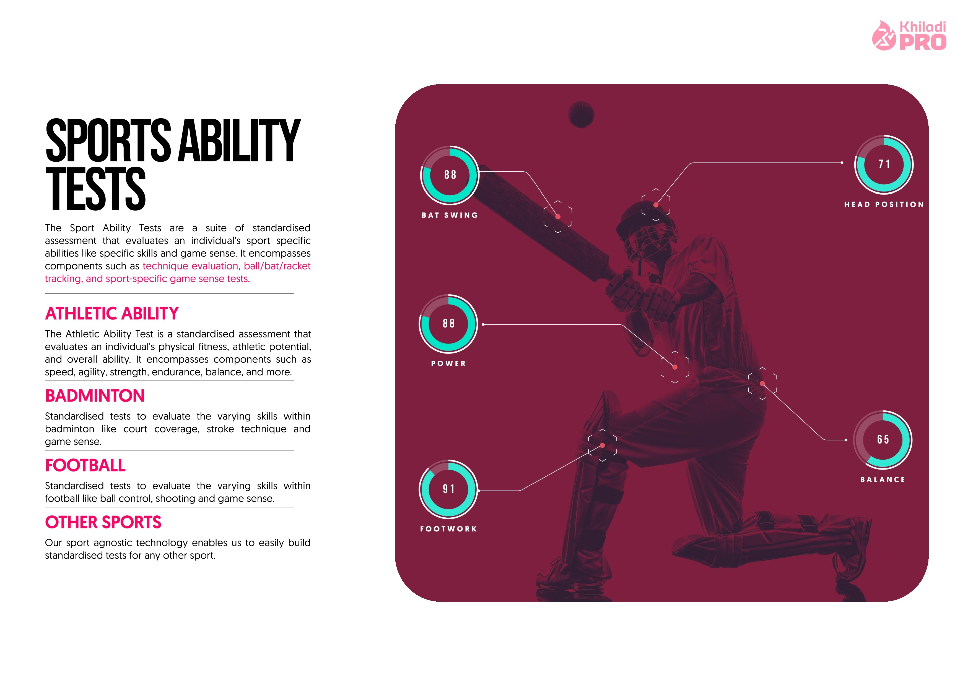

CONCLUSION
Undertaking this internship on Sports Analysis and Data Management has been a transformative and intellectually rewarding experience. It provided a unique opportunity to apply classroom knowledge to real-world scenarios, particularly within the ever-evolving and competitive field of sports. The internship enabled me to not only understand the theoretical foundations of data analytics but also to explore how data is collected, processed, visualized, and interpreted to enhance athletic performance and strategic planning in sports.

Throughout the course of this internship, I worked with various types of sports data – ranging from player statistics and performance metrics to team dynamics and historical records. I became familiar with tools such as Microsoft Excel, Khiladi Pro(for basic data manipulation), Tableau, and even sport-specific analytical platforms. These tools helped in cleaning raw data, creating visualizations, and uncovering patterns that might otherwise go unnoticed. I realized that data management is not just about handling numbers, but about telling a story – a story that can drive key decisions, predict future trends, and optimize team strategies.

One of the key takeaways from this internship was learning how data analytics can help coaches and managers in making informed decisions. For instance, performance indicators such as player workload, recovery time, fitness tracking, strike rate, economy rate, and average scores can provide a comprehensive view of a player's consistency and areas of improvement. These insights can also help in injury prevention and workload management – two essential elements in maintaining athlete longevity.
In conclusion, this internship has not only enhanced my technical and analytical capabilities but also inspired me to think critically about how data can influence outcomes in the sports industry. It reaffirmed my interest in sports analysis as a career path and provided a solid foundation for future academic and professional pursuits. I am grateful for the opportunity and look forward to applying the skills and knowledge gained here to contribute meaningfully to the world of sports.
REFERENCES

1. Alamar, B. C. (2013). Sports Analytics: A Guide for Coaches, Managers, and Other Decision Makers. Columbia University Press.

2. Davenport, T. H. (2014). Analytics in Sports: The New Science of Winning. International Journal of Sports Science & Coaching, 9(1), 1–6.

3. Hughes, M., & Bartlett, R. (2002). The use of performance indicators in performance analysis. Journal of Sports Sciences, 20(10), 739–754.

4. Rein, R., & Memmert, D. (2016). Big data and tactical analysis in elite soccer: Future challenges and opportunities for sports science. SpringerPlus, 5(1), 1-13.

5. Wright, C., Atkins, S., & Jones, B. (2013). The role of performance analysis within the coaching process. International Journal of Performance Analysis in Sport, 13(1), 240–261.

